**Expedite Portal User Guide:**

This portal was created for the main purpose of helping provide the users a platform where they can expedite incidents and view history of all the expedited incidents by them which are still not yet closed. It consists of two main pages, the home page and the expedited incidents page.

**Expedite Portal – Home Page**

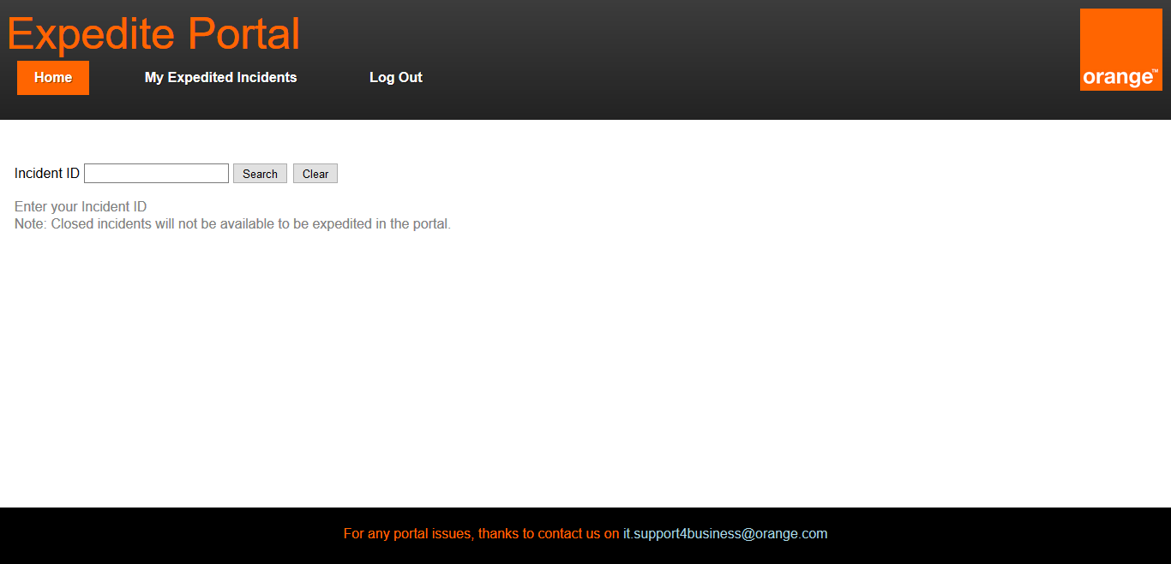

In this page the user can search for any Incident number by typing the Incident ID and pressing on the “Search” button. After searching for the incident the details of the incident will be shown and whether it is available for expediting or it has already been expedited. Incidents that are closed will not be available on the portal for expediting. Moreover any Incident which has not yet been reflected in the portal will take around 30 minutes to be available for expediting on the portal. If the Incident is not expedited the user can press on the “Expedite” button which will show the user the following view.

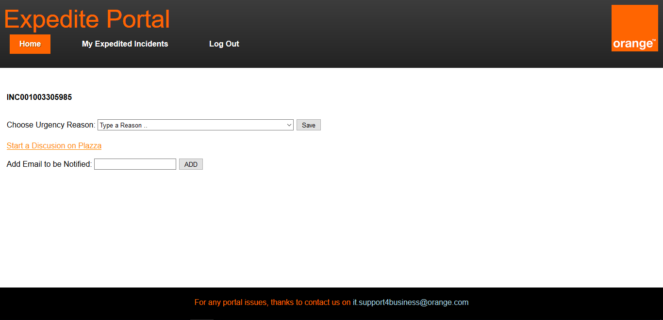

Here the user can choose the urgency reason upon which they desire the incident to be expedited by searching for a reason in the list or by manually selecting from the dropdown list. The user has the option of starting a discussion on Plazza about that certain incident by clicking on the link as shown.

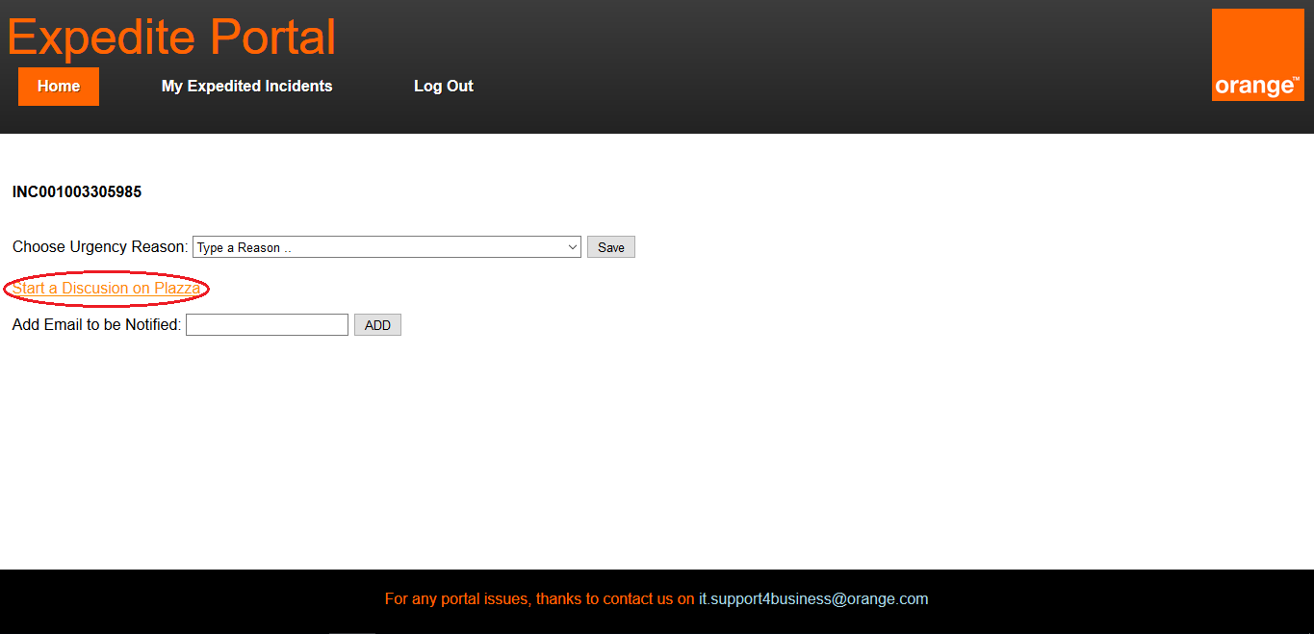

Also the user can specify emails to be notified about the expediting process by typing the email in the “Add Email to be Notified” and pressing the “ADD” button. A list will be shown consisting of the emails that will be notified about the expediting process. The example below shows what appears when the user types “[example@domain.com](mailto:example@domain.com)” and presses “ADD” button.

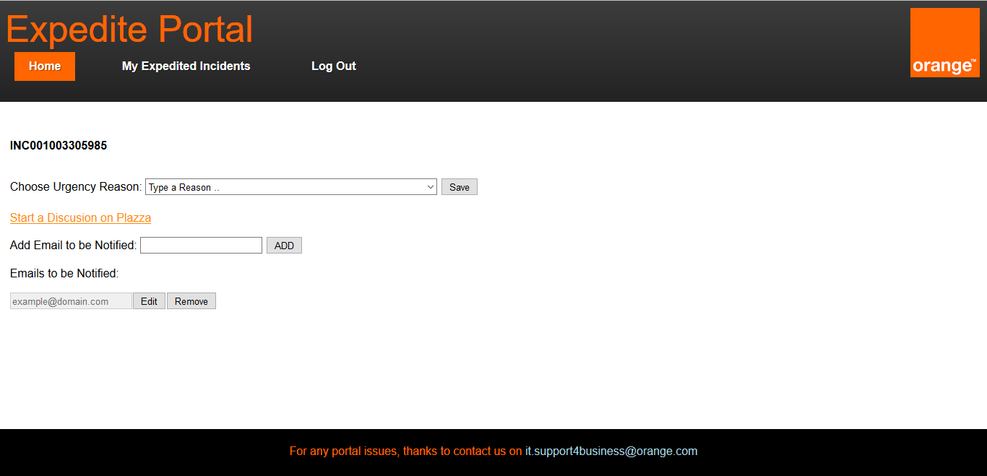

The user can add more emails by typing the email in the “Add Email to be Notified” and pressing on the “ADD” button. Each email in the list can be edited or removed.

**Expedite Portal – My Expedited Incidents**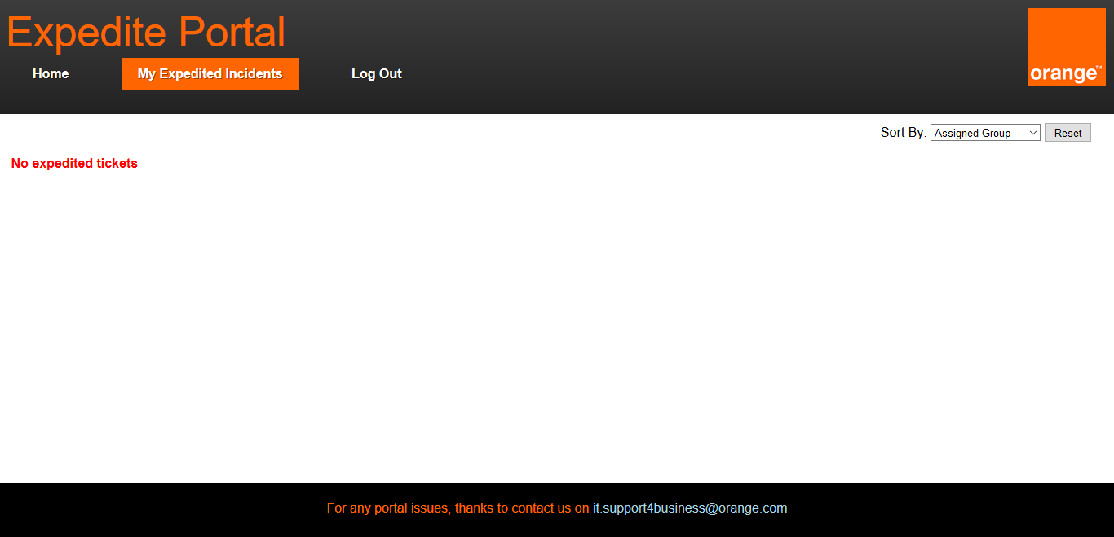

In this page the user can view all the incidents expedited by them which are not closed. The user can order the table ascendingly with all the columns using the “Sort by” section at the top left corner as shown in the image below. Upon selecting the column to sort, the table will instantly be sorted.

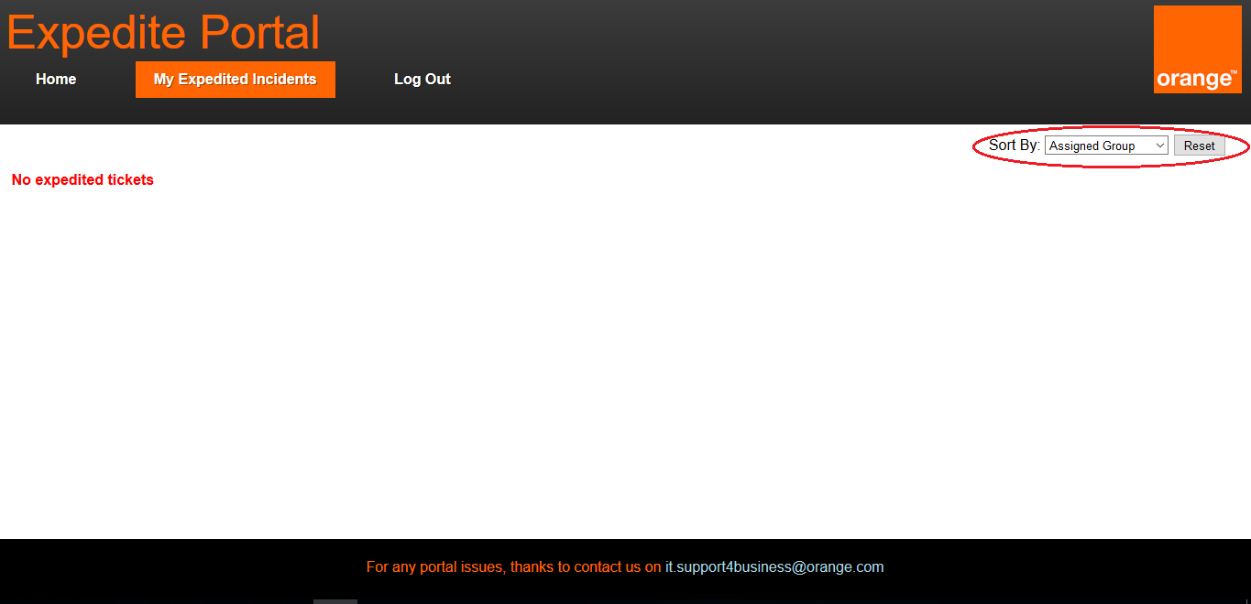

**Expedite Portal – Other Features**

Throughout the whole portal, any incident in a table view is clickable as shown below.

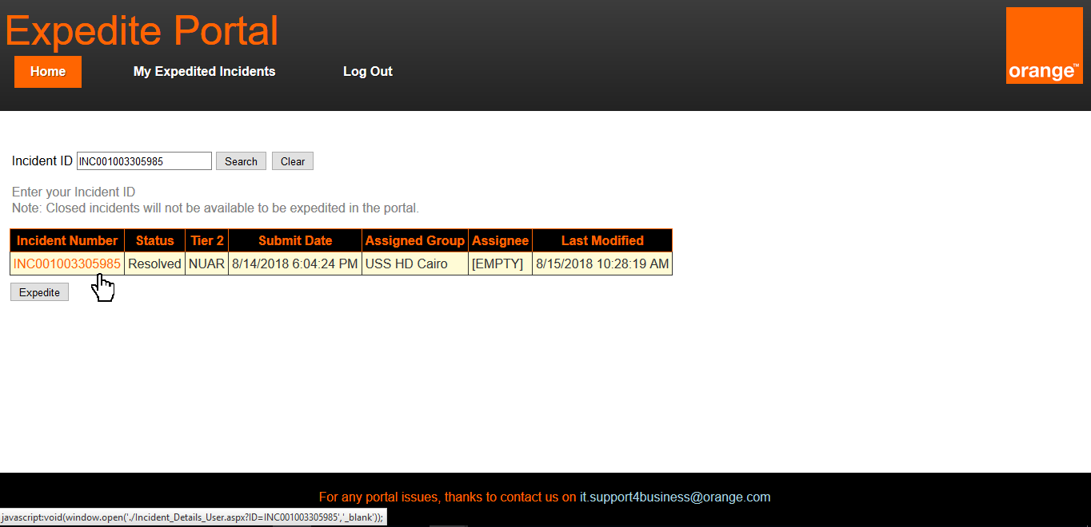

Upon clicking on an incident the following page will open in a new tab containing more information about the incident.

